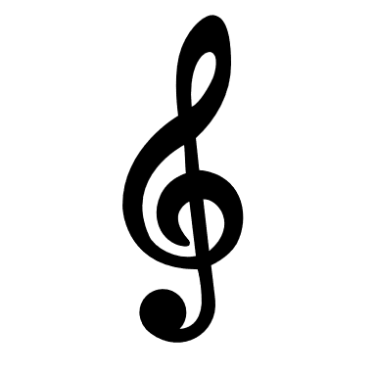Music Bingo
Complete a bingo (or 2) with these boxes and return to Mrs. Smith when school resumes.
Read about your favorite musician and make a poster. | Write a song of your own using quarter notes, half notes, eighth notes and their rests. | Write a paragraph about a song of your choice. | Go to sfskids.org and play a game of your choice.
Make your own musical instrument out of an item around your house and play along to a song. | Draw a picture inspired by a song by the composer of the month, Phillip Glass. | Listen to a song by the composer of the month, Phillip Glass, and write a story inspired by the song. | Watch a video by One Voice Children’s choir on youtube. Write a paragraph about why you would join the One Voice Children’s Choir.
Go to nyphilkids.org and play some games. | On YouTube, find the song “Do Re Mi” from the Sound of Music and sing along. | Practice an instrument around your house for 15 minutes. | Describe a song you hear with a few sentences. Tempo? Dynamics? What else do you notice?
Pick a favorite song and dance to the music! Get your family to dance with you. | Sing a song for someone in your family. | On YouTube, find Rhythm Clap Along Level 2 and say rhythms along with the video. | Write a paragraph about your favorite activity in music class. Why do you like this activity?

