Diskin- 8th Physical Science
1. Read a science-related article. Write an article summary.
2. From the article, write 5 words for which the definition is unknown. Write a possible definition based on context.
3. From the article, write 5 examples of jargon (words particular to a field or activity) for which the definition is unknown. Write a possible definition based on context.
4. Create a mnemonic to aid memorization of Electromagnetic Spectrum, from largest wavelength to smallest, or smallest to largest.
5. Create a mini poster diagraming Wave properties. Include brief definitions in layman’s terms.
6. Create flash cards or other tool to aid memorization of Wave properties.

Communication is available via rdiskin@bgs66.org or via our Google Classroom.

Writing a SUMMARY of an article
The purpose of a summary is to give the reader a clear, objective picture of the original text. Most importantly, the summary restates only the main points of a text or a lecture without giving examples or details, such as dates, numbers or statistics.
Guidelines for writing a summary of an article:
• State the main ideas of the article.
• Identify the most important details that support the main ideas.
• Write your summary in your own words; avoid copying phrases and sentences from the article unless they’re direct quotations.
• Express the underlying meaning of the article, not just the superficial details.
• Your summary should be about one third of the length of the original article.
Your summary should include:
Introduction
• Start with a summary or overview of the article which includes the author’s name and the title of the article.
• Finish with a thesis statement that states the main idea of the article.
Body Paragraphs
• The number of paragraphs in your summary depends on the length of the original article.
• Your summary should be about one third the length of the original article. For a one-paragraph summary, discuss each supporting point in a separate sentence. Give 1-2 explanations for each supporting point. For a multi-paragraph summary, discuss each supporting point in a separate paragraph.
• Start each body paragraph with a topic sentence.
• Each paragraph focuses on a separate main idea and just the most important details from the article.
• Put the ideas from the essay into your own words. Avoid copying phrases and sentences from the article.
• Use transitional words and phrases to connect ideas.
Concluding Paragraph
• Summarize the main idea and the underlying meaning of the article.

*A thesis statement usually appears at the end of the introductory paragraph of a paper, and offers a concise summary of the main point or claim of the essay, research paper, etc.^{[1]} It is usually expressed in one sentence, and the statement may be reiterated elsewhere. It contains the topic and the controlling idea.
There are two types of thesis statements: direct and indirect. The indirect thesis statement does not state the explicit reasons, while the direct thesis statement does. If one writes, "I love New York for three reasons," the fact that he or she loves New York is the topic, and "three reasons" are an indirect thesis statement. The essay will contain the three reasons. If one writes, "I love New York because of the food, the jazz clubs and the Broadway Shows," it is a direct thesis statement that tells what each section or body paragraph is going to be about.^{[2]}
The thesis statement is developed, supported, and explained in the course of the paper by means of examples and evidence. Thesis statements help organize and develop the body of the writing piece. They let readers know what the writer's statement is and what it is aiming to prove. A thesis statement does not necessarily forecast organization of an essay, which can be more complex than its purpose.

Article Title __________________________________________________________________________________________

1. Word ______________________________________
Possible Definition based on Context _______________________________________________________________
_____________________________________________________________________________________________
2. Word ______________________________________
Possible Definition based on Context _______________________________________________________________
_____________________________________________________________________________________________
3. Word ______________________________________
Possible Definition based on Context _______________________________________________________________
_____________________________________________________________________________________________
4. Word ______________________________________
Possible Definition based on Context _______________________________________________________________
_____________________________________________________________________________________________
5. Word ______________________________________
Possible Definition based on Context _______________________________________________________________
_____________________________________________________________________________________________
1. Jargon ______________________________________
Possible Definition based on Context _______________________________________________________________
_____________________________________________________________________________________________
2. Jargon ______________________________________
Possible Definition based on Context _______________________________________________________________
_____________________________________________________________________________________________
3. Jargon ______________________________________
Possible Definition based on Context _______________________________________________________________
_____________________________________________________________________________________________
4. Jargon ______________________________________
Possible Definition based on Context _______________________________________________________________
_____________________________________________________________________________________________
5. Jargon ______________________________________
Possible Definition based on Context _______________________________________________________________
_____________________________________________________________________________________________

The Electromagnetic Spectrum
The electromagnetic (EM) spectrum is the range of all types of EM radiation. Radiation is energy that travels and spreads out as it goes – the visible light that comes from a lamp in your house and the radio waves that come from a radio station are two types of electromagnetic radiation. The other types of EM radiation that make up the electromagnetic spectrum are microwaves, infrared light, ultraviolet light, X-rays and gamma-rays.
You know more about the electromagnetic spectrum than you may think. The image below shows where you might encounter each portion of the EM spectrum in your day-to-day life.
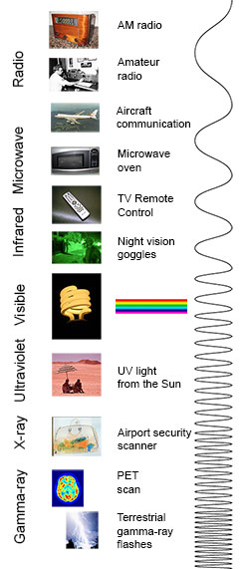
The electromagnetic spectrum from lowest energy/longest wavelength (at the top) to highest energy/shortest wavelength (at the bottom). (Credit: NASA's Imagine the Universe)

Radio: Your radio captures radio waves emitted by radio stations, bringing your favorite tunes. Radio waves are also emitted by stars and gases in space.
Microwave: Microwave radiation will cook your popcorn in just a few minutes, but is also used by astronomers to learn about the structure of nearby galaxies.
Infrared: Night vision goggles pick up the infrared light emitted by our skin and objects with heat. In space, infrared light helps us map the dust between stars.
Visible: Our eyes detect visible light. Fireflies, light bulbs, and stars all emit visible light.
Ultraviolet: Ultraviolet radiation is emitted by the Sun and are the reason skin tans and burns. "Hot" objects in space emit UV radiation as well.
X-ray: A dentist uses X-rays to image your teeth, and airport security uses them to see through your bag. Hot gases in the Universe also emit X-rays.
Gamma ray: Doctors use gamma-ray imaging to see inside your body. The biggest gamma-ray generator of all is the Universe.

Is a radio wave the same as a gamma ray?
Are radio waves completely different physical objects than gamma-rays? They are produced in different processes and are detected in different ways, but they are not fundamentally different. Radio waves, gamma-rays, visible light, and all the other parts of the electromagnetic spectrum are electromagnetic radiation.
Electromagnetic radiation can be described in terms of a stream of mass-less particles, called photons, each traveling in a wave-like pattern at the speed of light. Each photon contains a certain amount of energy. The different types of radiation are defined by the the amount of energy found in the photons. Radio waves have photons with low energies, microwave photons have a little more energy than radio waves, infrared photons have still more, then visible, ultraviolet, X-rays, and, the most energetic of all, gamma-rays.

Measuring electromagnetic radiation
Electromagnetic radiation can be expressed in terms of energy, wavelength, or frequency. Frequency is measured in cycles per second, or Hertz. Wavelength is measured in meters. Energy is measured in electron volts. Each of these three quantities for describing EM radiation are related to each other in a precise mathematical way. But why have three ways of describing things, each with a different set of physical units?
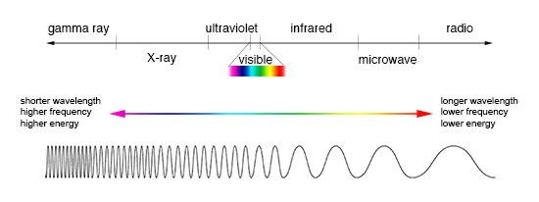
Comparison of wavelength, frequency and energy for the electromagnetic spectrum. (Credit: NASA's Imagine the Universe)
The short answer is that scientists don't like to use numbers any bigger or smaller than they have to. It is much easier to say or write "two kilometers" than "two thousand meters." Generally, scientists use whatever units are easiest for the type of EM radiation they work with.
Astronomers who study radio waves tend to use wavelengths or frequencies. Most of the radio part of the EM spectrum falls in the range from about 1 cm to 1 km, which is 30 gigahertz (GHz) to 300 kilohertz (kHz) in frequencies. The radio is a very broad part of the EM spectrum.
Infrared and optical astronomers generally use wavelength. Infrared astronomers use microns (millionths of a meter) for wavelengths, so their part of the EM spectrum falls in the range of 1 to 100 microns. Optical astronomers use both angstroms (0.00000001 cm, or 10⁻⁸ cm) and nanometers (0.0000001 cm, or 10⁻⁷ cm). Using nanometers, violet, blue, green, yellow, orange, and red light have wavelengths between 400 and 700 nanometers. (This range is just a tiny part of the entire EM spectrum, so the light our eyes can see is just a little fraction of all the EM radiation around us.)
The wavelengths of ultraviolet, X-ray, and gamma-ray regions of the EM spectrum are very small. Instead of using wavelengths, astronomers that study these portions of the EM spectrum usually refer to these photons by their energies, measured in electron volts (eV). Ultraviolet radiation falls in the range from a few electron volts to about 100 eV. X-ray photons have energies in the range 100 eV to 100,000 eV (or 100 keV). Gamma-rays then are all the photons with energies greater than 100 keV.
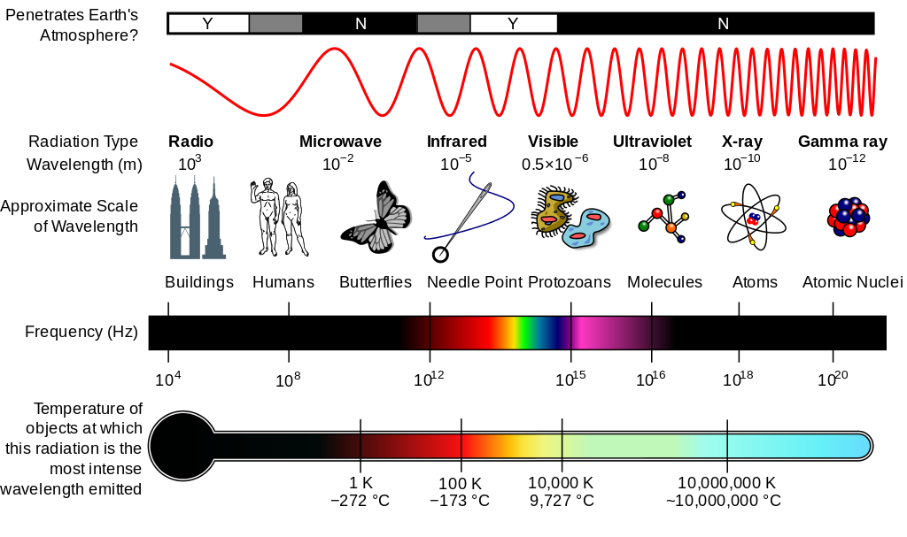

What is a Wave?
So waves are everywhere. But what makes a wave a wave? What characteristics, properties, or behaviors are shared by the phenomena that we typically characterize as being a wave? How can waves be described in a manner that allows us to understand their basic nature and qualities?
A wave can be described as a disturbance that travels through a medium from one location to another location. Consider a slinky wave as an example of a wave. When the slinky is stretched from end to end and is held at rest, it assumes a natural position known as the equilibrium or rest position. The coils of the slinky naturally assume this position, spaced equally far apart. To introduce a wave into the slinky, the first particle is displaced or moved from its equilibrium or rest position. The particle might be moved upwards or downwards, forwards or backwards; but once moved, it is returned to its original equilibrium or rest position. The act of moving the first coil of the slinky in a given direction and then returning it to its equilibrium position creates a disturbance in the slinky. We can then observe this disturbance moving through the slinky from one end to the other. If the first coil of the slinky is given a single back-and-forth vibration, then we call the observed motion of the disturbance through the slinky a slinky pulse. A pulse is a single disturbance moving through a medium from one location to another location. However, if the first coil of the slinky is continuously and periodically vibrated in a back-and-forth manner, we would observe a repeating disturbance moving within the slinky that endures over some prolonged period of time. The repeating and periodic disturbance that moves through a medium from one location to another is referred to as a wave.
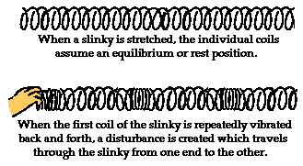

What is a Medium?
But what is meant by the word medium? A medium is a substance or material that carries the wave. You have perhaps heard of the phrase news media. The news media refers to the various institutions (newspaper offices, television stations, radio stations, etc.) within our society that carry the news from one location to another. The news moves through the media. The media doesn't make the news and the media isn't the same as the news. The news media is merely the thing that carries the news from its source to various locations. In a similar manner, a wave medium is the substance that carries a wave (or disturbance) from one location to another. The wave medium is not the wave and it doesn't make the wave; it merely carries or transports the wave from its source to other locations. In the case of our slinky wave, the medium through that the wave travels is the slinky coils. In the case of a water wave in the ocean, the medium through which the wave travels is the ocean water. In the case of a sound wave moving from the church choir to the pews, the medium through which the sound wave travels is the air in the room. And in the case of the stadium wave, the medium through which the stadium wave travels is the fans that are in the stadium.
Particle-to-Particle Interaction
To fully understand the nature of a wave, it is important to consider the medium as a collection of interacting particles. In other words, the medium is composed of parts that are capable of interacting with each other. The interactions of one particle of the medium with the next adjacent particle allow the disturbance to travel through the medium. In the case of the slinky wave, the particles or interacting parts of the medium are the individual coils of the slinky. In the case of a sound wave in air, the particles or interacting parts of the medium are the individual molecules of air. And in the case of a stadium wave, the particles or interacting parts of the medium are the fans in the stadium.
Consider the presence of a wave in a slinky. The first coil becomes disturbed and begins to push or pull on the second coil; this push or pull on the second coil will displace the second coil from its equilibrium position. As the second coil becomes displaced, it begins to push or pull on the third coil; the push or pull on the third coil displaces it from its equilibrium position. As the third coil becomes displaced, it begins to push or pull on the fourth coil. This process continues in consecutive fashion, with each individual particle acting to displace the adjacent particle. Subsequently, the disturbance travels through the medium. The medium can be pictured as a series of particles connected by springs. As one particle moves, the spring connecting it to the next particle begins to stretch and apply a force to its adjacent neighbor. As this neighbor begins to move, the spring attaching this neighbor to its neighbor begins to stretch and apply a force on its adjacent neighbor.

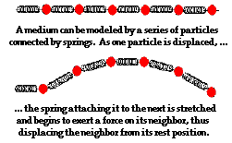

A Wave Transports Energy and Not Matter
When a wave is present in a medium (that is, when there is a disturbance moving through a medium), the individual particles of the medium are only temporarily displaced from their rest position. There is always a force acting upon the particles that restores them to their original position. In a slinky wave, each coil of the slinky ultimately returns to its original position. In a water wave, each molecule of the water ultimately returns to its original position. And in a stadium wave, each fan in the bleacher ultimately returns to its original position. It is for this reason, that a wave is said to involve the movement of a disturbance without the movement of matter. The particles of the medium (water molecules, slinky coils, stadium fans) simply vibrate about a fixed position as the pattern of the disturbance moves from one location to another location.
Waves are said to be an energy transport phenomenon. As a disturbance moves through a medium from one particle to its adjacent particle, energy is being transported from one end of the medium to the other. In a slinky wave, a person imparts energy to the first coil by doing work upon it. The first coil receives a large amount of energy that it subsequently transfers to the second coil. When the first coil returns to its original position, it possesses the same amount of energy as it had before it was displaced. The first coil transferred its energy to the second coil. The second coil then has a large amount of energy that it subsequently transfers to the third coil. When the second coil returns to its original position, it possesses the same amount of energy as it had before it was displaced. The third coil has received the energy of the second coil. This process of energy transfer continues as each coil interacts with its neighbor. In this manner, energy is transported from one end of the slinky to the other, from its source to another location.
This characteristic of a wave as an energy transport phenomenon distinguishes waves from other types of phenomenon. Consider a common phenomenon observed at a softball game - the collision of a bat with a ball. A batter is able to transport energy from her to the softball by means of a bat. The batter applies a force to the bat, thus imparting energy to the bat in the form of kinetic energy. The bat then carries this energy to the softball and transports the energy to the softball upon collision. In this example, a bat is used to transport energy from the player to the softball. However, unlike wave phenomena, this phenomenon involves the transport of matter. The bat must move from its starting location to the contact location in order to transport energy. In a wave phenomenon, energy can move from one location to another, yet the particles of matter in the medium return to their fixed position. A wave transports its energy without transporting matter.

Waves are seen to move through an ocean or lake; yet the water always returns to its rest position. Energy is transported through the medium, yet the water molecules are not transported. Proof of this is the fact that there is still water in the middle of the ocean. The water has not moved from the middle of the ocean to the shore. If we were to observe a gull or duck at rest on the water, it would merely bob up-and-down in a somewhat circular fashion as the disturbance moves through the water. The gull or duck always returns to its original position. The gull or duck is not transported to the shore because the water on which it rests is not transported to the shore. In a water wave, energy is transported without the transport of water.
The same thing can be said about a stadium wave. In a stadium wave, the fans do not get out of their seats and walk around the stadium. We all recognize that it would be silly (and embarrassing) for any fan to even contemplate such a thought. In a stadium wave, each fan rises up and returns to the original seat. The disturbance moves through the stadium, yet the fans are not transported. Waves involve the transport of energy without the transport of matter.

In conclusion, a wave can be described as a disturbance that travels through a medium, transporting energy from one location (its source) to another location without transporting matter. Each individual particle of the medium is temporarily displaced and then returns to its original equilibrium positioned.

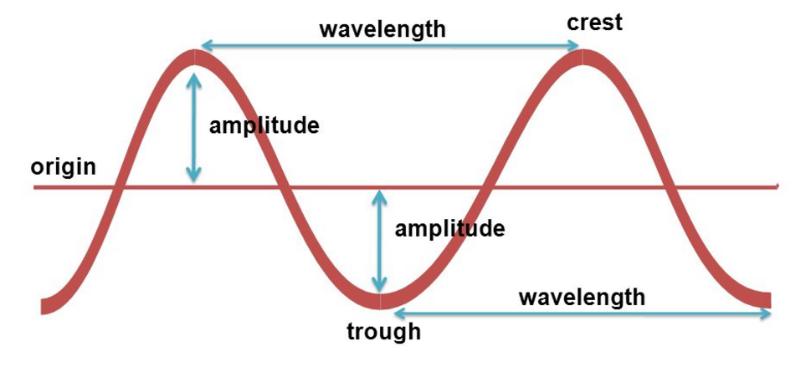
Parts of a Wave
Origin- baseline of the wave
Crest- Highest point of the wave
Wavelength- Distance between crests or troughs
Amplitude- Distance between the origin and crest or trough
Trough- Lowest point of the wave

